**VIEWING THE AOS PROJECTED DELIVERY**

**In COIN**

Click on the FPMIS Pivot Table link available in the Budget Management module of each office under the FAOR Summary tab. The data displayed is ‘*as at end of the previous month*’.

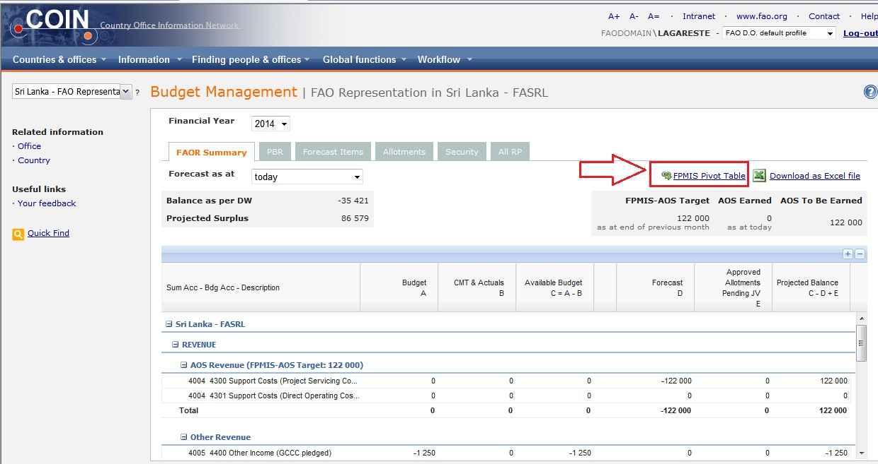

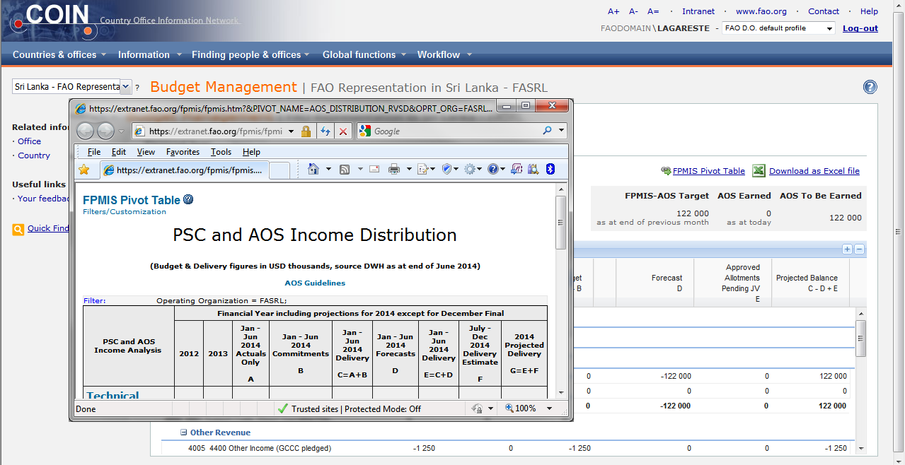

**In FPMIS**

Click on ‘*PSC and AOS income distribution*’

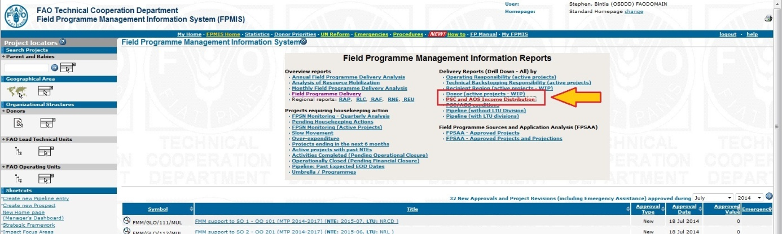

Click on ‘*Filter/Customization*’

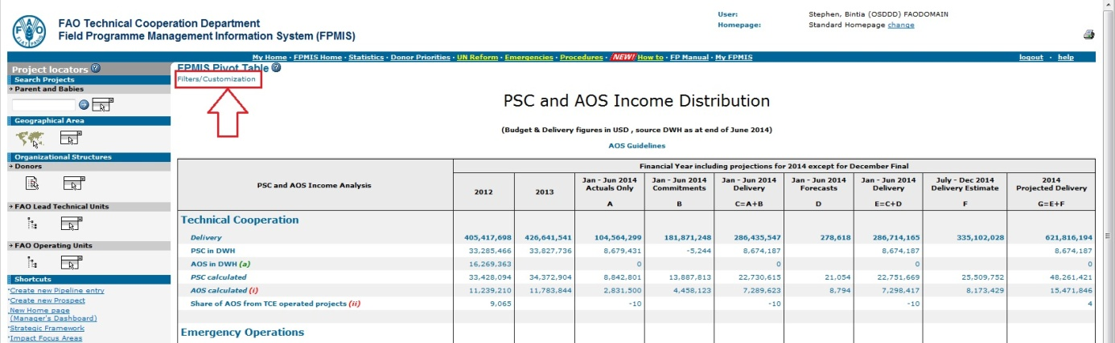

Select the office code in the ‘*Operating Organization’* box, and click on ‘*Apply*’ to view the FPMIS Pivot Table.

